PowerMatcher i3

Datawarehouse and Reporting
System Test Report

Authors: Robert-Jan Sips (IBM)



Version: 0.5
Revision: 1
Date: 31-08-2012



Table of Contents

1. Introduction 5
2. Example reports 6
References 11

Figures

Tables

Version History

Revision | Description | Author
1 | Initial draft. | R.H.J. Sips (IBM)

Introduction

Identification
The full identification of this document is: “PowerMatcher i3 - Datawarehouse and Reporting System test report”.

Background
PowerMatcher i3 (instrumented, interconnected and intelligent) is the initial component-based implementation in Java of the PowerMatcher concept, as an intermediate step between the original PowerMatcher 3 implementation in .net by ECN towards a reference implementation of PowerMatcher in Java for the Flexible Power Alliance.

The PowerMatcher Datawarehouse and Reporting solution is a reference implementation for a dimensional (Kimball) datawarehouse structure on the Powermatcher data.

Purpose and scope
This document provides an overview of the Dimensions and facts contained in the Powermatcher Datawarehouse and the Cognos framework and reports on top of this datawarehouse.

This document is intended to accompany the deliverables of the PWM as a Service reference implementation and assumes access to Cognos BI.

Intended Audience
This specification is intended for future implementations of datawarehousing on top of the Powermatcher i3 platform.

Example reports
In this section we describe 3 example reports for the DWH system, and 2 Realtime example reports.

Portal / System-overview
The Powermatcher Portal page shows an overview of the available reports (right-hand side, package Datawarehouse and Realtime) and the System-overview report.

System-overview
The System-Overview report depicts the current measurements for the test-setup used in the reference implementation, with realtime updates of PV-generation, refrigerator and freezer status, etc.

The System-overview report can be found in the Example Reports folder.

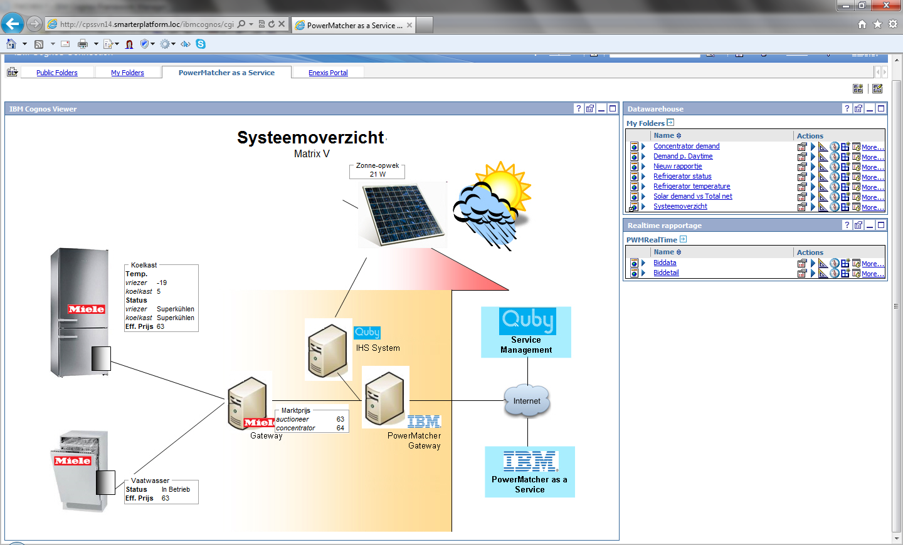

Concentrator Demand

The Concentrator demand report shows the demand curves (min, max, effective) reported by Concentrator1 in the MatrixV cluster, plotted over the time-dimension.
Clicking on the time dimension allows for dimensionally navigating the data (i.e. zooming in to a different detail level, or zooming out to, e.g. month level).

The Concentrator demand report can be found in the Example Reports folder.

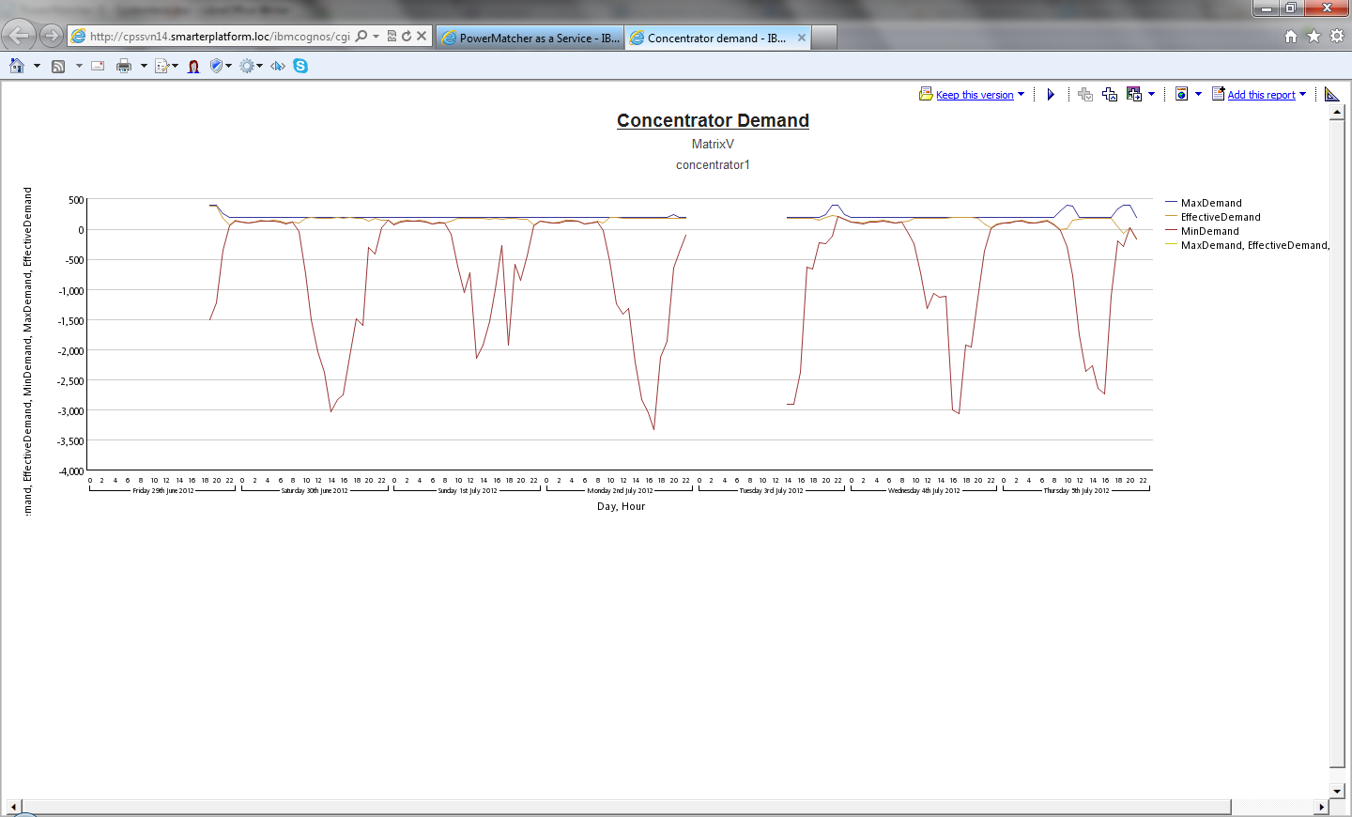

Refrigerator status
The Refrigerator status report shows the measurements done by the Refrigerator and Freezer agent in the MatrixV cluster over time.

The Refrigerator status demand report can be found in the Example Reports folder.

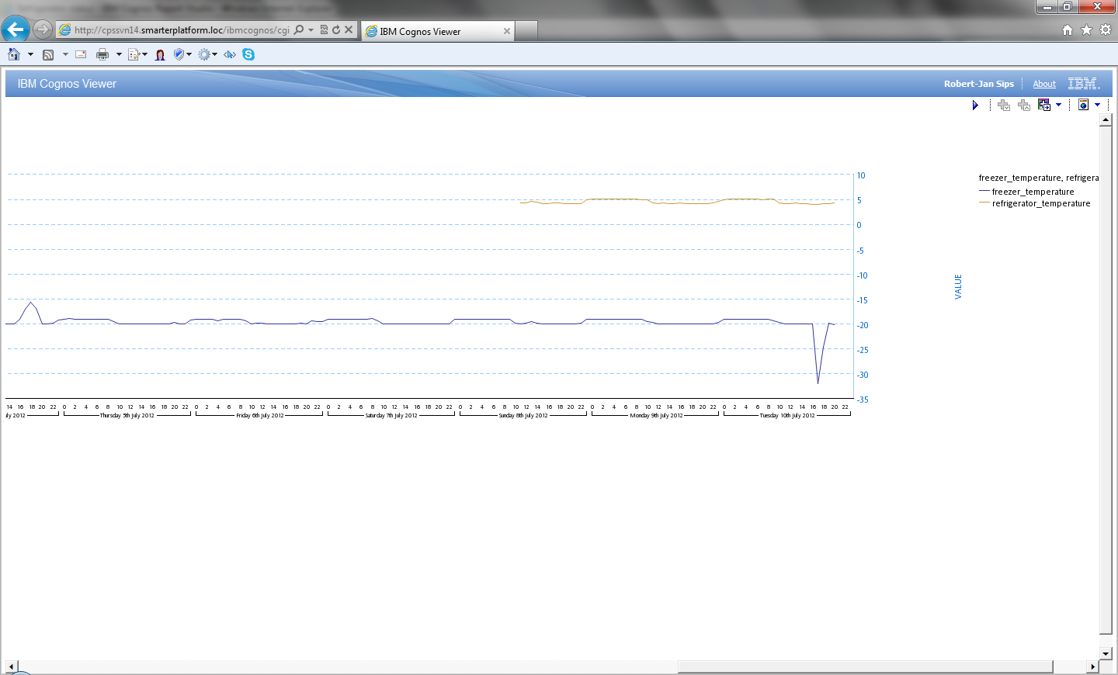

Realtime – Biddata

The Biddata report shows an overview of all bids in the operational system, within a certain time interval.
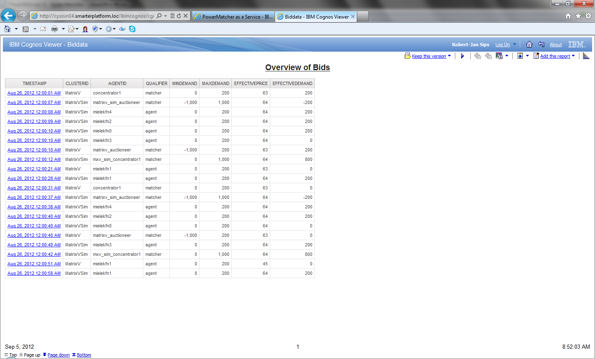

Realtime – Biddetail
The Biddetail report can be accessed through the link specified in the Biddata report, to see the detail of a single bidcurve.
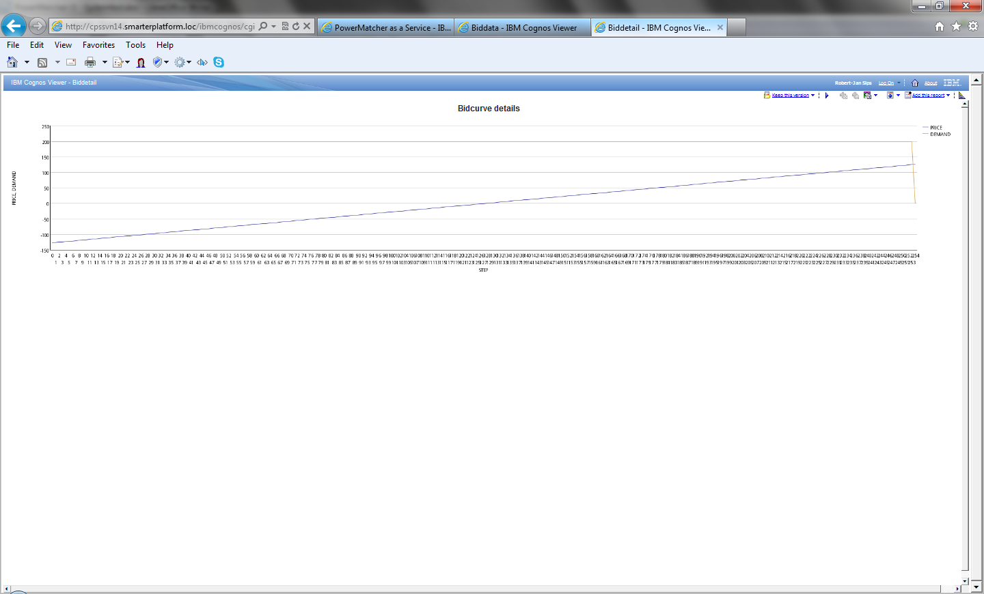
References

 | Kimball, Ralph; Margy Ross (2002). The Data Warehouse Toolkit: The Complete Guide to Dimensional Modeling (2nd ed.). Wiley. ISBN 0-471-20024-7. | 2002

